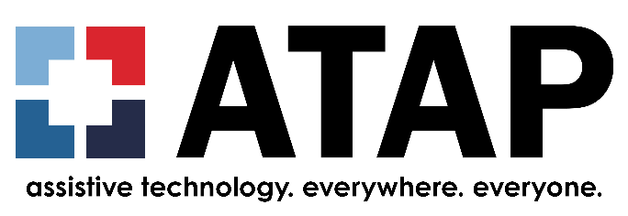

ATAP Job Announcement

Project Coordinator
The Association of Assistive Technology (AT) Act Programs (ATAP) is seeking a versatile, self-motivated Project Coordinator to join our team. We're looking for a true jack-of-all-trades who thrives on variety and is eager to jump in wherever they're needed. We want someone ready to evolve with us, where learning and initiative open the door to new responsibilities and a larger role on the team. Our organization is entering an exciting period of growth and positive change, and this is a great opportunity to be part of it.

Location
100% Remote, with occasional travel to conferences/meetings to exhibit and present; must reside in one of the contiguous (lower 48) United States

Type
Full-time with flexible schedule

Salary
Starting at $88,000, commensurate with experience

About the Role
The Project Coordinator will support a wide range of activities across our organization and play a central role in keeping our work organized and on track. No two days look the same, and the right person enjoys wearing many hats. Training will be provided, so a willingness to learn is just as important as existing experience. This position offers the opportunity to be part of a fast-growing organization on a mission to ensure everyone knows about assistive technology (AT) before they need it, and has access to it when they do.

Key Responsibilities
- Project Coordination: Keep projects, deadlines, and deliverables on track across multiple areas, proactively following up to ensure tasks are completed and nothing falls through the cracks
- Events: In collaboration with the team, plan, coordinate, and implement in-person and virtual events such as the Leadership Symposium, Communities of Practice (COPs), and conduct follow-up activities
- AT Learning Hub- Help develop and maintain the AT Learning Hub and guide educator collaborators in creating courses
- Communications & Content: In collaboration with the team, develop and maintain products and website content including the Vendor Directory and events page, news articles, and social media
- Fundraising & Membership: Coordinate and implement the yearly membership dues drive, and assist the Executive Director with fundraising and leveraged funding, including online campaigns, grant writing, and networking as needed
- Data & Reporting: Support data collection and organization for grant and program reporting
- Technical Support: Provide technical support to Assistive Technology Act Programs and the public as the need arises.
- And other duties as assigned

Qualifications

Required
- Bachelor's degree
- At least 3 years working with an Assistive Technology Act Program [or specify: device demonstration, device loan, reuse, state financing] or other qualifying experience
- Strong organizational and communication skills
- Ability to manage multiple priorities and adapt to changing needs
- Attention to detail
- Ability to work in a remote environment and manage tasks independently
- Excellent analytical, written, and verbal communication skills
- Ability to travel as needed

Preferred
- 5+ years of experience working with at least one of the Assistive Technology Act Programs [or specify: device demonstration, device loan, reuse, training, or information & assistance]
- Understanding of the mechanics of systemic interagency coordination and collaboration
- Skilled in tailoring technical assistance to the nuances of the different administrative structures that implement State AT Programs (i.e., universities, state agencies, and private non-profit agencies)
- Substantial depth of content knowledge and a proven track record of successfully designing and delivering the integrated continuum of AT Act services
- Master's degree
- Assistive Technology certification, such as RESNA ATP
- Experience with digital accessibility (e.g., accessible documents, websites, and content)
- Experience with platforms such as Airtable and AI tools (e.g., ChatGPT, Claude)
- Experience with tools such as Canva and WordPress,

What We Offer
- Great benefits package, including health, vision, and dental insurance, and a matched retirement plan
- Vacation, personal time, and sick leave
- Flexible schedule

To Apply
Please send your resume and cover letter to Jeannie Krull at jeannie.krull@ataporg.org.

