
Comparison of Caption Companion, Xander, and Captify Pro

Device | HIPPA Compliant | Battery Life & Speed | Website | Special Features | Subscriptions
Caption Companion  $1600  8” Tablet  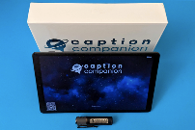  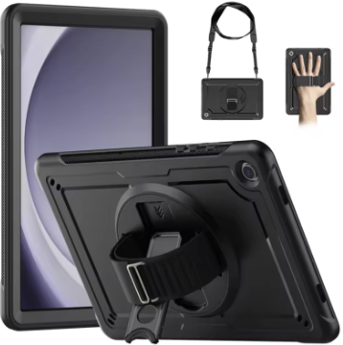  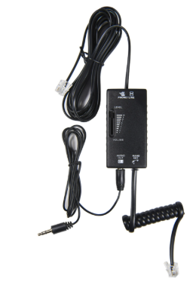 | Yes as long as an app is not used  All info deleted within 24-72 hours.  Info can be deleted sooner  No Internet  No data collected | 11 hours of continuous use  When fully charged, the smart mic (omni-directional)  can go about 6 hours’ worth of active captioning  Quick, real-time captioning | Caption Companion - Premier Visual Voice  Training videos  01 - Unboxing  02 - Tablet screen basics  03 - Captioning screen basics  04 - SmartMic  05 - Wi-Fi  07 - Included smart accessories  08 - Saving captions to computer  09 - Floating caption window on computer | Comes with uniquely paired Bluetooth SmartMic for increased accuracy, 4-channel wireless mic set available. Smart mic has an audio jack built in, useful in online meetings to capture audio from the meeting as well as speakers in the room  Phone adapters available for desks and cell phones  Protective case available  Can connect via custom HDMI cable or wirelessly mirror to large screen or projector  Can capture audio directly from FM systems, audio/hearing loops, assistive listening devices. You must use proprietary audio cables. Can be used to connect remotely to a professional human CART captioner  Optional lock screen. Can set up using PIN, pattern, password or face recognition  Option to export transcripts can be enabled as part of approved accommodation  Supported in 26 languages in offline mode: many more languages available online. English will have the best accuracy.  The following features only work when connected to the internet: custom words, wireless screen mirroring, and connecting remotely to a live human captioner.  Show labels include sounds like laughter, applause, and music  Unable yet to distinguish voices  Y splitter allows you to increase the accuracy of the caption companion with the audio cable plugged into the device and another cable with an earbud for listening  Vysor.io app allows you to transfer information if approved by your organization from the caption companion to the computer | No subscriptions, monthly fees, or other charges

Device | HIPPA Compliant | Battery Life & Speed | Website | Special Features | Subscriptions
Xander Glasses  $5000 (now)  3 new products anticipated soon from $1,000 - $2,500 (soon)  Glasses, 4.6 ounces  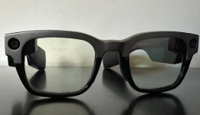  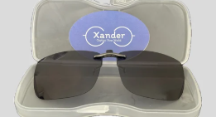 | Yes as long as the app is not used | 3 hours of continuous use  Quick, real-time captioning | XanderGlasses  Behind the Glasses 2024: See How XanderGlasses Captions Display for Users  XanderGlasses User Guide July 2025.pdf | SOC-2 Compliant for safety of data. Only you can access your conversations. No cloud service or human or machine will hear conversations captured by the glasses. No data is collected.  Ready to go out of the box. Push a button, put on the glasses, and you’ll see real-time captions of what people are saying superimposed in your field of view.  After pressing the on button on the glasses, it can take 20-30 seconds for them to turn on.  Tout 90% accuracy in noisy environments such as restaurants, city streets, and public venues.  The glasses allow you to look at the speaker and your surroundings instead of down at a screen.  The frames have a titanium front. The lenses have full UV protection and meet ANSI Z77.1 standards.  The frames come with sunglass clip-ons. Single-vision prescription lenses are available at no extra cost.  Comes with two remote dual noise-canceling microphones  Stand-alone, offline operation for use anywhere.  Speech-to-text technology is built into glasses.  Binocular display for comfortable reading.  The text can be displayed on the top, middle, side or bottom. Recommend displaying text in the middle so the listener feels you are looking directly at them when speaking.  The Caption Display can be adjusted from the free smartphone app, allowing users to choose caption size, position, brightness, and language  The user can use voice commands to power down the glasses with the command “Command Off”.  If your glasses are in the sleep mode for 15 minutes, they will automatically power off.  The wireless microphone will enhance accuracy. | No subscriptions. Existing customers receive updates free of charge

Device | HIPPA Compliant | Battery Life & Speed | Website | Special Features | Subscriptions
Captify Pro  $749  Glasses, 1.6 ounces  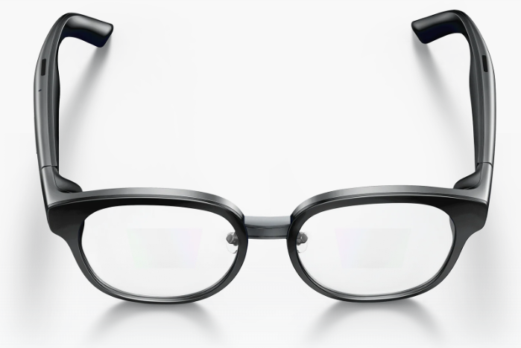 | No, must use an app to set up the glasses | 4 hours of continuous use. Charges in about 40 minutes  When Wi-Fi or cellular service was used, the lag response for the conversation was 30-45 seconds (*note below) which was not conducive; however, when the glasses are placed in the offline mode, the speed is comparable to the other devices. (*Note: this may depend on internet stability, our hotspot may have caused this issue because this was not the case when others used it.) | Captify -- Captions for real life  TRANSFORMATIONAL TECH: These Captify Pro Glasses changed how I work | Designed specifically from the ground up for the deaf and hard of hearing.  Requires the use of an app to set up the glasses. A Bluetooth connection is used to connect the app with the glasses.  Adds speakers’ names with captioning (Not available yet).  Uses directional microphones.  Comes with adjustable nose bridges.  Can be used with the user’s prescription. Captify accepts vision insurance. Supports prescription lenses.  The smartphone is an integral part of the Captify glasses. Videos on how to use the Captify glasses are built into the app.  The glasses are designed to be connected to the internet in some way. Transcription can be automatic or off-line.  Can save conversations. Microphone sources can be glasses, phones, or sometime in the future a Bluetooth mic.  The brightness of the display impacts the battery life.  The user has the option for single-eye display. In the future, the user will be able to adjust the text position, text size and text density.  The user taps the side of the glasses to start transcribing. The transcription is displayed on the app.  Supports 40+ languages and the glasses can be used as a translator (English to Spanish etc.) in addition to straight captioning. | Free version- unlimited offline conversations  Pro Version - $15 month includes more accurate captions, more accurate translations, speaker differentiation, conversation summaries, custom word recognition, cloud backup and sync, and ask AI.  Ask AI scans your conversations and brings the answer back such as what time was the dinner reservation?

