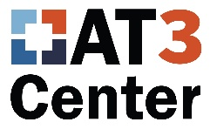

AT Act Programs Contribute to

AT Transition Planning
Written by Gayl Bowser

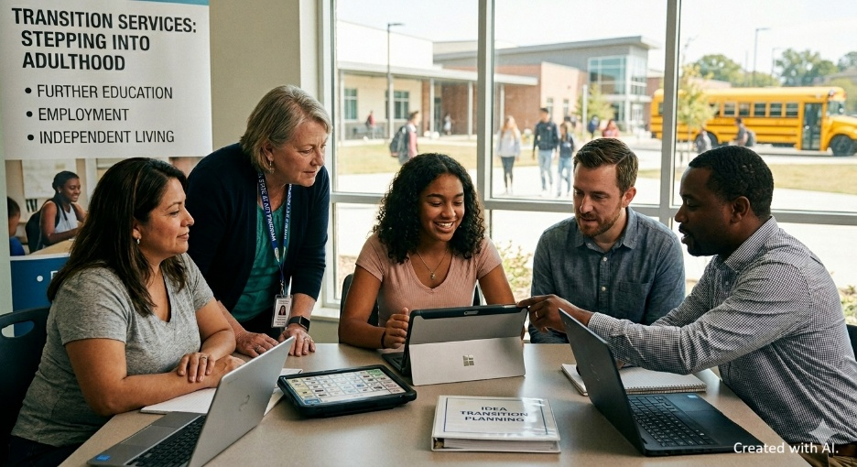

AT Transitions in Schools Under IDEA
The Individuals with Disabilities Education Act (IDEA) defines post-secondary transition as a coordinated, results-oriented process designed to help students with disabilities move from high school to adult life. Transition planning must be documented in a student’s Individualized Education Program (IEP). Team members include students, parents and families, school staff, and outside agencies. It is common that vocational rehabilitation or developmental disabilities services are included, but the agencies to be included are not specified in the law. When Assistive Technology Act programs and independent living centers are involved in transition planning, it opens opportunities for students who use assistive technology (AT).
State AT Act Programs offer resources to help individuals with disabilities of all ages navigate available technology and funding options. Core 2024 AT Act Priorities & Activities encourage programs to develop resources for Device Loans & Demonstrations; Reutilization; Alternative Financing (AFP); and State Leadership. One current Key Focus Area of AT Act programs is Transition Services, which is defined as “Strengthening support for youth transitioning from school to adulthood and individuals moving from institutions into community living”.
IDEA requires that transition planning focus annually on three primary areas: further education, employment, and independent living. Regular planning begins during the first IEP in effect when a student turns 16, although many states require starting at age 14. Goals are developed based on the student's individual strengths, preferences, and interests at that age. Schools must provide transition services such as specialized instruction, community experiences, and vocational evaluations to help students reach their goals.
Some transition plans are built with a focus on increasing independence in adult living settings such as housing, employment, recreation, and finances. In this case, the school program will include activities like opportunities for employment internships, driving instruction, and money management.
A different set of activities may be included in a transition plan for a student who will need long-term support. Options such as supported or group home living, supported employment, and advocacy and guardianship would be explored in a plan for a student with higher support needs. AT Act programs that partner with schools in transition planning will have different kinds of AT and different kinds of resources to offer, depending on whether goals are developed with a focus on adult independence or supportive services.
AT transitions include discussion about device functions and features needed before and after the transition in order to ensure continuity of use in a new setting. Features that are needed (e.g., portability, durability, specific functions), may change during transition. Supports in adult settings are different from the supports planned for and provided by school IEP teams. While public schools are required to provide AT for students who need them, adult AT users must know how to locate and request the services, supports, and funding they need.

Skills for AT Transitions
AT activities and services that are included in a transition plan will vary depending on the degree to which a student will be independent, but all students need specific elements in a transition plan in order to continue using AT when they move to post-secondary settings. These elements fall into three categories:
- Effective transition planning, which includes transition for AT use;
- Independence with AT; and
- Self-Determination and Self-Advocacy skills.

Effective Transition Planning
Transition plans involve an ongoing process. The plan provides a framework, but the transition planning process should remain flexible to allow for necessary adjustments. Good transition plans that address AT ask questions like these.
- How does this AT currently help the individual in this area?
- Will the same AT be useful in the new environment?
- What new things will the individual need to do after the transition?
- Will new AT be needed to do the new things?
The chart below suggests AT options that a student may use for specific areas, both in school and after the transition.
AREA | AT EXAMPLES
Instruction | Software for productivity, accessibility features found in operating systems, screen readers, speech-to-text, and online classes
Community experiences | Choice-making boards and scripted communication devices, survival signs, devices for travel support, social stories in print or video
Post-school adult living | environmental control devices, accessibility supports such as ramps, adapted cooking tools,
Functional vocational evaluation | AT in the form of work accommodations, task completion apps, and visual schedules
Daily living skills | Digital personal assistants, AT for self-feeding and grooming, voice command lights, curtains, etc.

A Plan for Miguel
Miguel is 14 years old. He was diagnosed with Down Syndrome at birth. He is outgoing and enjoys frequent conversations with friends and adults about baseball and fishing. Sometimes socializing takes him off task, especially during his work experience in the cafeteria. He currently uses some visual schedule boards in the cafeteria to remember the steps for his job. At his annual review, his IEP team developed his long-term transition goals and initial transition activities.
Miguel and his team focused on the fact that his current educational program did not include community activities. His education program had, so far, been located within the school. The team decided that Miguel needed community experience to help him be as independent as possible. They planned that he would begin to participate in community recreation activities and community work experience. For these experiences, he will need new visual schedules on cards or in a notebook for his new routines, and the team decided to begin to introduce him to a sequencing app that would work with his personal phone to eventually replace the visual schedules.

Independence in AT Use
The more an individual can make independent choices and take independent actions when they use AT, the more likely it is that AT will be a valued tool during and after the transition. A transition planning team should ask questions like these when they focus on transitions that include AT.
- What will the students need to learn to set up their AT hardware or software?
- What will the student need to learn to ask another person for assistance with AT operation?
- What will the student need to learn about what to do if the AT breaks down?
- Is the student able to describe his or her strengths and weaknesses?

To be effective users of AT, individuals must develop skills in four areas (adapted from Light, 2003). They are:
- Functional skills in the area for which the AT was chosen (e.g., reading, writing, math, communication).
- Operational skills needed to make the AT work (e.g., turn on the AT, load textbook files from the server, adjust the reading rate and highlighting.)
- Strategic skills for considering when to use the technology (e.g., using the same textbook files on a school computer and on a home computer, deciding when to use a communication device instead of voice),
- Social skills for using the technology around other people and to help other people understand the reasons for its use (e.g., explain to teachers why and how AT helps a student; talk with peers about AT use; adjust AT settings so that devices do not interfere with classroom learning.

By looking closely at a student’s AT skills in function, operational, strategic, and social use, the transition team can identify goals and benchmarks that will help to ensure the student is as independent as possible with their AT.

Diane’s Independence
Diane, 16, had always known that she wanted to be a scientist. She avidly watches scientific television documentaries and participates eagerly in science lab activities in one of her general education classrooms. Because of a learning disability, her reading skills are below average, and she has used AT accommodations such as audio books, text-to-speech, and extended time on tests since she was in elementary school. She is continuing to strengthen her reading skills but will probably need AT Accommodation when she pursues her dream of college.
Diane’s IEP team included independence, her coordinated set of activities. They focused on decreasing the amount of support she needs to set up her technology, helping her learn to find and manage book files on her own, and loading audiobook files into her phone and computer.

Self Determination
Self-determination is critical to post-school success and particularly important to ensure continuity of AT use after transitions. Advocacy and self-advocacy were the key ingredients to successful AT use after school.

Self-determined students are skilled at:
- Choice making:
  - “I help choose whom to invite to my transition meetings.”
  - “I know how to ask for the AT that I need.”
- Decision making:
  - “I know how to make an informed decision.”
  - “I know what I like and don’t like about using AT.”
- Problem solving:
  - “I have completed a portfolio that contains important names, numbers, and email addresses.”
  - “I know how to get help when my AT is not working properly.”
- Goal setting:
  - “I know how to share my goals with others.”
  - “I view assistive technology as a tool to help me accomplish my goals.”
- Evaluation:
  - “I can describe my strengths and needs
  - “I can describe my strengths and needs related to using AT.”

Self-determination for Anna
Anna, 17, has cerebral palsy. Throughout school, she has been preparing for college in her school courses but wonders how her disability will impact her future. As she gets ready for college, she wonders what technology will be available at the school to help her complete writing tasks during her coursework and in her future jobs. In addition to the instructional activities in her transition plan, her IEP team will consider what services she may need to support her college participation.

How AT Act Programs can help with transitions
When AT Act Programs connect with other agencies that will support the student’s AT use in planning, independence, and self-advocacy, they can help to develop a variety of AT supports. Transitions work best for AT Users when long-term services and supports for AT are identified early, when students who use AT are actively engaged in the planning process, and when the students who use AT have self-determination skills.
Transition service delivery systems take advantage of the formal and informal professional partnerships that inform, direct, and coordinate transition services for youth with disabilities. A transition partnership that includes AT Act programs can help to mobilize resources for AT both before transitions and make sure that AT is a part of a dynamic and responsive transition service delivery system after student transitions to adult services. When they are included in transition planning, AT Act participation can help to make sure transitions are successful.

References
Iris Center (2026) Secondary Transition:Student-Centered Transition Planning
Acquired from https://iris.peabody.vanderbilt.edu/module/tran-scp/#content
Fried-Oken, M., Bersani, H., Anctil, T & Bowser, G. (1998). TechTransmitter. Portland, OR: Oregon Health Sciences University.
U.S. Department of Education (.gov) Transition Planning Requirements of IDEA 2004
Walters, C. & Allison, M. (2024). Center for Independent Living and their Role in the Transition Service Delivery System. Retrieved from https://ctci-umd.org/resources-publications

