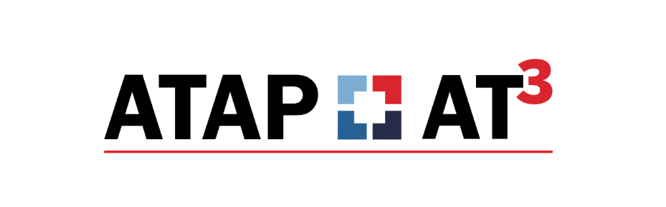

Ideas About AT Implementation
Article Written by Gayl Bowser for ATAP-AT3

Once Assistive Technology (AT) has been selected for an individual the AT work has just begun. The next step is in helping individuals develop effective AT use skills and increased independence in everyday routines and activities. When AT implementation works well, individuals can change what they are able to do in new ways by using technology. When AT implementation works well, changes are made in environments where the AT is used order to support participation and achievement. When implementation works well, AT helps people with disabilities increase the quantity, quality and independence of their participation in their own lives.

For all this to happen, AT support must be well planned. Teams review the information that was used to decide about AT need. As they do this, they ask themselves what should happen moving forward so AT can be used to foster learning and growth for this person. Some questions may include:
- What new capabilities do we expect to see for this individual?
- What environmental changes do we have to make to support the changes?
- What changes in the individual’s performance do we hope to see because of AT use?

There are several environmental management factors that significantly impact the ability of a person with a disability to develop new functional skills. Two of the most useful are organization of the environment and development of procedures for using AT. Each has important implications for everyone involved with AT implementation.

Organizing the Environment
The ways that the environment is organized and space is used has an enormous impact on technology integration of any kind. But it is especially meaningful when AT is included in everyday routines and activities. Effective environmental organization includes making sure people who use AT are visible and heard by others in the environment, that individuals using AT have a clear view of the environment, that high traffic areas for movement are clear, and that AT is accessible when needed. Both low-tech devices such as adapted spoons, slant boards and communication boards and high-tech computer and tablet options should be placed in the environment with attention to visibility, accessibility and distractibility.

AT implementation in Tim’s home environment
Tim is 12 years old. He attends school in his home school and is included part of the day in general education classrooms and part of the day in a resource room. Tim uses a high-tech AAC device at school and brings it home every day so that he can tell his family about his day and share the latest news about his friends. Tim likes school and is always happy to attend but getting him there has become a real chore for everyone.

At home in the morning, there is a daily struggle between Tim and his mom for him to get dressed and eat breakfast. There are arguments about what clothes to wear and what to have for breakfast. In addition to these issues, it is always difficult to get Tim’s communication device ready to go to school with him. The school bus often has to wait for him in the morning because he is not ready. It has become a problem that involves everyone, including kids who ride the bus with him.

Tim’s family asked for help. On a family visit, the consultant made several suggestions about the changes in the environment that might help with some of the morning difficulties. Here are some of the things she suggested.
- Lay out two sets of clothes for Tim so that he can see his choices before he goes to bed at night.
- Ask Tim to use his communication device to choose breakfast options.
- Create a visual chart that lists all the things that go in Tim’s backpack so that he can see what is needed every morning and begin to be more independent in getting ready for school.

Developing Procedures
Everyone has procedures for the things they do on a regular basis. You probably have routines for your morning coffee, going to the grocery store or driving to work. Procedures help us develop a sense of predictability and knowledge of what to do. They address routine tasks and save time. We can develop procedures for any predictable event. Procedures reduce transition time and reduce confusion about what to do. It may take us a while to identify the specific steps in a daily routine. We may have to practice how we do something several times before a procedure becomes clear. We explore, rehearse, practice and revise our procedures until we find a comfortable way of doing things.

Development of procedures which directly address technology can help AT to fit into daily routines and activities for people who use AT. Here’s how Tim’s family used AT solutions and developed procedures for his mornings.

Procedures for Tim’s morning use of AT:
- In the morning, Tim can pick one of the two sets of clothes to put on. Any changes or discussion about what to wear happens in the evening before he goes to bed. He and his family use his AAC device to have this discussion.
- The morning routine was developed using a single “breakfast” page for the communication device so that he can make choices and his mom can hear what he wants to eat.
- Right after Tim eats his breakfast, he puts the AAC device, charger and any other needed accessories in his backpack by the front door in a place where he can see it and get to it easily when the bus comes.

Conclusion
Effective implementation involves things that we can do to encourage high levels of involvement from the person who uses AT as well as minimal interference and distraction for others. and efficient use of time.

We have included a form called Environment Assistive Technology Walkthrough It is designed to be used as an observation tool by assistive technology specialists, educators, and anyone who wants to ensure that AT is well-managed. It takes into account individuals who use AT as well as the total environmental context for technology use. If you are offering professional learning opportunities about AT implementation or if you are focused on a particular individual, it’s a great opportunity to use this form to assess environments.

