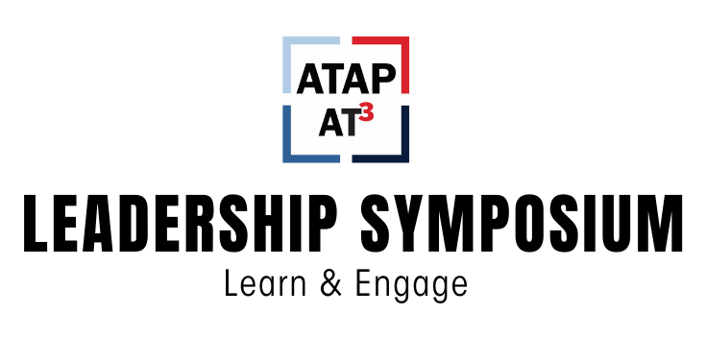

Speaker Biographies

Monday, February 23rd

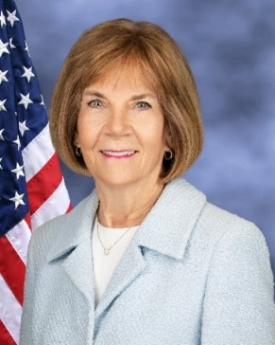
Mary Lazare - Principal Deputy Administrator, serving as the senior official performing the duties of the ACL Administrator and Assistant Secretary for Aging

Special Guest - Monday, February 23rd
Mary Lazare is the principal deputy administrator, serving as the senior official performing the duties of the ACL administrator and assistant secretary for aging. She was sworn in on March 3, 2025, returning to the ACL following service from 2017-2021.
Throughout a career focused on improving the health and well-being of people with disabilities and older adults, Mary has led social services and health care systems in building partnerships across industries and all levels of government, modernizing system infrastructure and leveraging new technology, and creating opportunities for innovation in order to better meet the needs of the people they serve.
During her prior tenure at ACL, Mary led the agency’s overall day-to-day operations and spearheaded several key initiatives, including an interagency task force focused on expanding employment opportunities for people with disabilities; a public-private partnership to prevent social isolation; and cross-sector collaboration to align health care and aging and disability services to improve health outcomes and reduce costs.
Before joining ACL, she served as Vice President for Home and Community-Based Services for Lutheran Senior Services, overseeing the operations of home health, hospice, and private duty services to improve patient outcomes and developed partnerships among aging services, health care systems and providers to better meet the individual needs of older adults. In earlier roles, she served as Vice President of Senior Care Facilities and Community Health Ministries at Ascension Health, Vice-President of Senior Services and Home Care Services at BJC Health Care, and Executive Director for the Jewish Center for the Aged. She also has served on the board of the Mid-East Area Agency on Aging Foundation of St Louis, the Continuum of Care Committee of the Catholic Health Association, the American Hospital Association Governing Council for Post-Acute Care Services, and a number of other civic and professional organizations.
Mary received her undergraduate degree from the University of Missouri, a master’s degree in gerontology from Lindenwood University, and a Master of Business Administration and Management from Maryville University of Saint Louis.


Eric Buehlmann – National Disability Rights Network Deputy Executive Director for Public Policy

National/Federal Perspectives – Monday, February 23rd
Eric Buehlmann has been with NDRN since March of 2007, first as a Senior Public Policy Analyst, now as the Deputy Executive Director for Public Policy. In these roles, he has worked to increase appropriations and enact legislation helpful to the P&A network.

In January 1993, Eric joined the disability community when he had a stroke in his last semester of law school. One month in the hospital and two months in a rehabilitation hospital were followed by a year and a half recovery, during which he was gradually able to return to his work and legal education. Today, Eric identifies as someone with a disability, as his stroke left him with no vision from his nose left, left-sided weakness and attention issues that have a daily impact on his activities.

Prior to joining NDRN, Eric worked for United States Sen. James Jeffords in a variety of positions from 1995 through 2007, ultimately serving as Legislative Counsel. While with Sen. Jeffords, he focused on campaign and election law, labor policy, banking and housing and judiciary matters, in addition to other policy areas. Eric graduated from the Washington College of Law at American University in 1995 with a J.D., and from Lehigh University in 1990 with a B.S. in Accounting.

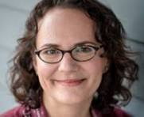
Maggie Koziol - Council of State Administrators of Vocational Rehabilitation Chief Executive Officer

National/Federal Perspectives – Monday, February 23rd
Maggie Koziol joined CSAVR as Chief Executive Officer in January 2026. She brings more than 20 years of experience leading workforce, education, and disability-inclusive systems across government, consulting, and the nonprofit sector. Maggie has worked at the intersection of vocational rehabilitation, workforce policy, and systems reform at Deloitte, Alvarez & Marsal, USAID, and the World Bank, and most recently served as Executive Director of a community-based mental health provider in Washington, DC.

Throughout her career, Maggie has partnered with federal and state agencies, employers, and advocates to strengthen public systems, advance inclusive employment, and improve outcomes for people facing barriers to opportunity. As CEO, she is committed to championing the national VR system, supporting state agencies, and advancing CSAVR’s role as a trusted leader in policy, partnerships, and workforce innovation.

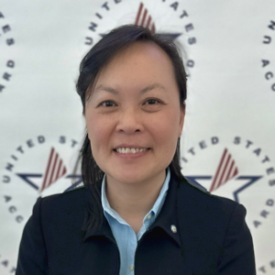
Katherine Eng – Senior ICT Accessibility Specialist Office of Technical and Information Services

National/Federal Perspectives – Monday, February 23rd
Kathy Eng serves as a Senior ICT Accessibility Specialist with the Access Board. Eng provides technical assistance on Section 508 with a focus on conformance testing. Eng is co-lead of the ICT Testing Baseline Portfolio, co-facilitator of the W3C Accessibility Conformance Testing Task Force, and chair of the Best Practices subcommittee in the Accessibility Community of Practice (ACOP) of the Chief Information Officers’ Council. Prior to joining the Access Board, Eng developed the Trusted Tester process and training program. Eng has worked in federal accessibility and accommodations since 1999 and has a Master’s degree in Rehabilitation Engineering.

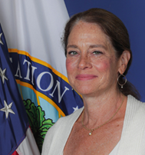
Katy Neas - The Arc of the United States, Chief Executive Officer

National/Federal Perspectives – Monday, February 23rd
Katy is the current CEO of The Arc of the U.S., a visionary leader who has devoted her career to disability rights, and she has deep connections in the field. Previous to her role with The Arc, she worked for the Department of Education where she served as Deputy Assistant Secretary in the Office of Special Education and Rehabilitative Services. Prior to that role, she was Executive Vice President of Public Affairs for the American Physical Therapy Association (APTA) and for Easterseals. She is widely regarded for her bipartisan and collaborative work, earning her roles including Past Chair of the Consortium for Constituents with Disabilities (CCD). Earlier in her career, Katy served as Legislative Assistant to Senator Tom Harkin and the U.S. Senate Subcommittee on Disability Policy, where she worked on landmark legislation such as the Americans with Disabilities Act (ADA) and the Individuals with Disabilities Education Act (IDEA). Katy holds a B.A. from Georgetown University.

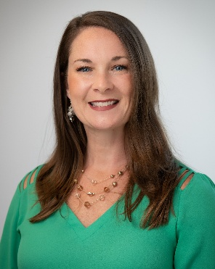
Amanda Goodenow – CAPABLE National Center Strategic Partnership Specialist

Aging in Place Partnerships, Monday, February 23rd
Amanda Goodenow began her occupational therapy career over 20 years ago in acute care in Topeka, Kansas, after earning her master’s degree from the University of Central Arkansas. She joined the Colorado Visiting Nurse Association (CVNA) in 2011 as a home health occupational therapist and became a certified CAPABLE (Community Aging in Place–Advancing Better Living for Elders) clinician in 2017.

She later advanced to CAPABLE Clinical Support, where she directed clinical operations, led a team of RNs and OTs, managed the partnership with Habitat for Humanity of Metro Denver, and guided program evaluation, outreach, and growth strategy. In 2020, she joined the Johns Hopkins School of Nursing CAPABLE team as a consultant and now serves the CAPABLE National Center as Strategic Partnership Specialist, supporting program expansion across the U.S. and internationally.

Alongside these leadership roles, she continues to maintain a caseload of CAPABLE clients at CVNA.


Emily Nabors – National Council on Aging Associate Director of Innovation

Aging in Place Partnerships, Monday, February 23rd
In the field of falls prevention for over 15 years, she has conducted applied research, developed tools and educational materials, and provided professional training on falls prevention and home modification to support community living. She has extensive experience in building cross-sector coalitions and partnerships, and she manages projects including the ACL Innovation Lab, the National Falls Prevention Fellowship, and a grant to support the development of state falls prevention coalitions. Previously, Emily was Program Manager of the Fall Prevention Center of Excellence at the University of Southern California (USC) Leonard Davis School of Gerontology. She has a Master of Science degree in Gerontology from the Leonard Davis School of Gerontology.

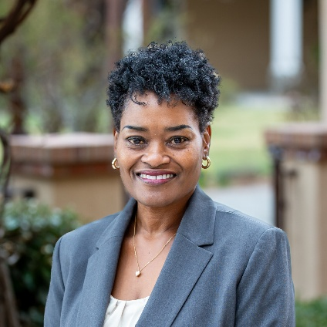
Yakima K. Black, M.S., CAPS – Louisiana Assistive Technology Access Network Director

Aging in Place Partnerships, Monday, February 23rd
Yakima Black is the President & CEO of the Louisiana Assistive Technology Access Network (LATAN) which is the 21st Century Assistive Technology (AT) Act program for the state of Louisiana. A Clinical Rehabilitation Counselor, for more than 27 years, Yakima has served as the chief executive of non-profit organizations providing health and human services. With an extensive background in federal and state compliance regulations, administrative and financial management, as well as continuous quality assurance and improvement, Yakima recently led LATAN through national accreditation supporting adherence to CMS regulations resulting in licensure with the Louisiana Board of Pharmacy as a durable medical equipment (DME) and medical supply provider.

She proudly serves her alma mater, Southern University and A&M College as an adjunct professor within the College of Nursing and Allied Health within the Department of Rehabilitation Services, Disability Studies, and Counseling. Further, Yakima serves on the board of the Association of Assistive Technology Act Programs and is a member of the American College of Healthcare Executives. Perhaps most important and most gratifying, she’s an advocate and family member of a group of diverse individuals of all ages living with chronic medical conditions and physical limitations. Yakima is dedicated to creating opportunities that expand the continuum of care for underserved populations that include integrated health and rehabilitative services at the community health level.

Tuesday, February 24th

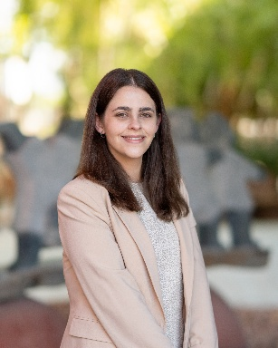
Jordyn Zimmerman

Keynote, Tuesday, February 24th
Jordyn Zimmerman is a passionate educator and disability advocate. After being diagnosed as autistic at a young age, she did not receive access to augmentative communication, via iPad, until the age of 18. She now thrives on boldly showing up and redefining what is possible in learning spaces and throughout the broader community — and has personal experience challenging the status quo, which is featured in the documentary, This Is Not About Me.

Jordyn collaborates with organizations around the world, is Board Chair of the national nonprofit CommunicationFIRST, and served as a two-time appointee on The United States President's Committee for People with Intellectual Disabilities. She previously earned her Bachelor's degree in Education Policy from Ohio University, her Master's of Education at Boston College, and her Masters of Business Administration from Quantic School of Business and Technology. More at www.JordynZimmerman.com

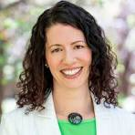
Erica Mohr – pLink leadership, Senior Executive Coach

Endnote – Dare to Lead Workshop, Tuesday, February 24th
Erica Mohr earned her Professional Certified Coach designation from the International Coaching Federation. She is a Certified Dare to Lead™ Facilitator and holds certifications in the Leadership Circle Profile™ 360 assessment tool, the iPEC Energy Leadership Assessment, the Leadership Challenge, and the DISC behavioral assessment.
Obsessed with impact, Erica Mohr is a high achiever and fiercely loyal client champion. Using curiosity, kindness, and collaboration, Erica supports her clients to shift outdated leadership paradigms to new beliefs that maximize business outcomes and personal well-being.
As a Coast Guard commander with over 20 years of leadership experience, Erica designed, deployed, and evaluated the service’s leadership development curricula—a large task for a 45,000-person military organization which must grow their executive talent from those recruited as 18-year-olds. While in the service, she co-founded the Coast Guard’s Women’s Leadership Initiative, a national nonprofit centered on increasing the retention of women in the Coast Guard.

Following her time in the Coast Guard, Erica served as the Executive Director of the Sasamani Foundation, an international organization dedicated to fighting poverty through women’s empowerment in East Africa. Erica continues to serve as the Board Chair and as a volunteer training Tanzanian Coaches to support the next generation of East African women leaders.

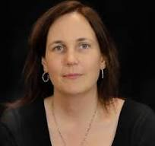
Rylin Rogers - Microsoft Accessibility Team Disability Policy Director

Microsoft and Accessibility, Tuesday, February 24th
Rylin Rodgers serves on Microsoft’s Accessibility Team as a Disability Policy Director. She strives to impact disability policy in the areas of technology, workforce and workplace. Rylin’s work is influences by her lived experiences with disability. She is dyslexic and has idiopathic pulmonary fibrosis, and the mother of two young adults with physical disabilities and medical complexity. Her family is ALL IN for disability policy.

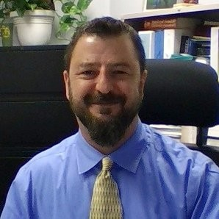
Tobias Orr – Director, Nebraska Assistive Technology Partnership (ATP)

Aging in Place Partnerships – Part II, February 24th
In this role, he leads statewide efforts to ensure individuals of all ages and all disability types can learn about, access, and benefit from assistive technology. Through ATP’s diverse programs, Nebraskans receive essential adaptive equipment as well as home and vehicle modifications that support independence and greater community participation.
Tobias also serves as the current co-chair of ATAP. With a career in the disability field that began in the early 2000s, he has worked across numerous settings and has extensive experience supporting individuals with a wide range of disability-related needs.

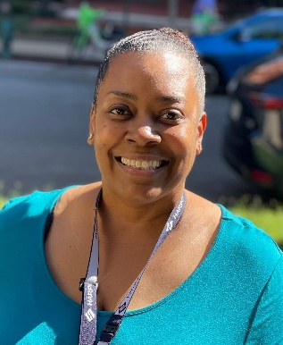
Davette Rucker - Program Manager for DC Assistive Technology Program

Aging in Place Partnerships – Part II, February 24th
Davette is an occupational therapist and has been in the field of disability and rehabilitation since 1998. Her background includes home modifications, low vision, wheelchair seating and positioning, smart home technology, and home and office decluttering and organizing.

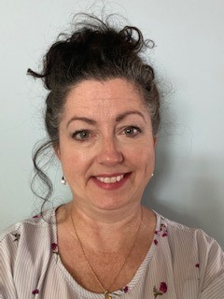
Amy Perron - Director of the Minnesota STAR Program

Aging in Place Partnerships – Part II, February 24th
Amy has been with STAR for 10 years, first serving as the Assistive Technology Specialist and for the last 3 years as Director. Prior to joining the STAR team Amy worked in the public sector as an assistive technology sales consultant for 10 years.

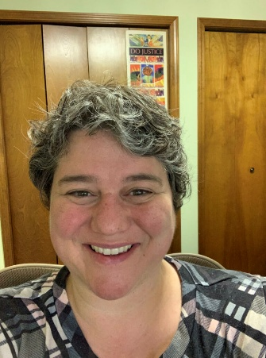
Aimee Sterk, LMSW – Director Michigan Assistive Technology Program

Aging in Place Partnerships – Part II, February 24th
Aimee is an autistic woman with multiple disabilities and has been working and living in the aging and disability community for over 25 years. She is also a mom to children with developmental disabilities. She started her career helping people transition out of nursing homes and progressed to policy and program development to support community living using assistive technology. She has worked with governmental task forces and audiences around the state and nation on inclusion, grant writing, nursing facility transition, financial literacy, disability, voting rights, effective communication, community-based long-term care, and assistive technology. As social policy chair for the League of Women Voters in Holland, Aimee coordinated a National Organization on Disability award-winning program to increase voter accessibility for older adults and people with disabilities in West Michigan. Aimee served on the national board of the Association of Assistive Technology Act Programs, the board of Southeast Ottawa Community Foundation, and was on the Outpatient Advisory Committee for Corewell Health. She has a B.A. in Psychology from Hope College and an M.S.W. from Michigan State University.

When not working, Aimee can be found reading, cooking, watching dramedies, and enjoying Michigan's four seasons of beautiful nature with her two children and spouse.

